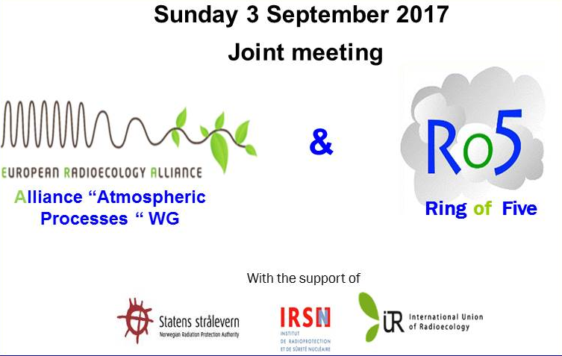
Tentative Programme (subject to change)

10:00 -10:45 - Welcome and Opening presentation
- Welcome O. Masson / H. Wershofen

Morning sessions
- Pu strange ratios in the ground-level atmosphere: H. Wershofen, J.W. Mietelski, R. Gurriaran, O. Masson,

- Ro5 report on past 5-year detections of anthropogenic radionuclides at trace levels in the European atmosphere. O. Masson
- Medical radioisotopes in waste as possible contributors to airborne radioactivity. Helmut W. Fischer
Coffee-break
- ⁸⁵Kr sampling and measurement: O. Connan,
- Estimating outdoor Radon and Thoron concentrations from High Volume Aerosol Filters. P. Steinmann
- Accidental release of ⁷⁵Se in Germany on December 2016: A. Dalheimer, T. Steinkopff
Lunch break
Afternoon session (open discussion)
- Presentation of subtasks:
- Iodine, Size distribution, Plutonium
- Who, What, When, How ?
- Funding

- Report on trace events (J. Kastlander / O. Masson / others)
- How to keep memory of our detections and make it in a valuable fit-for-purpose communication form
- Example: Focus on the iodine detection event (January / February 2017) in Europe

Poster session - Coffee-break and registration at the ICRER conference desk
17:00 –19:00 - Closing session and discussion

Oral presentation (morning session) will last 15 minutes and will be followed by 5 minutes maximum dedicated to questions.

Contact: olivier.masson@irsn.fr

