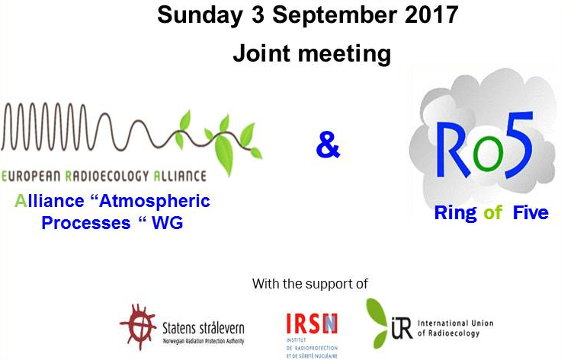
Final agenda

9:30 - Welcome - 10 :00
- Welcome H. Wershofen / O. Masson

Morning session (scientific questions)
- Pu strange ratios in the ground-level atmosphere: H. Wershofen, J.W. Mietelski, R. Gurriaran, O. Masson, R. Anczkiewicz, S. Conil, P. Jalinowski, R. Kierepko, E. Nalichowska, L. Pourcelot.
- Ro5 report on past 5-year detections of anthropogenic radionuclides at trace levels in the European atmosphere. O. Masson.
- Medical radioisotopes in waste as possible contributors to airborne radioactivity. H.W. Fischer.

Coffee-break
- Inhomogeneous ¹³⁷Cs activity distribution on the aerosol filter – case studies from the Czech Radiation Monitoring Network: M.Hyza, P. Rulik, H. Mala.
- Estimating outdoor radon and thoron concentrations from high-volume aerosol filters. P. Steinmann, D.M. Lienhard, A. Jörg and S. Estier.
- Accidental release of ⁷⁵Se in Germany on December 2016: A. Dalheimer, T. Steinkopff.
1:00 pm - 2:00 pm Lunch break and poster session
Afternoon session (organizational issues / open discussion)
- Presentation of subtasks and possible working groups:
- Iodine speciation, Size distribution, Plutonium, U, Po
- Enquiry results: “Sharing data; yes! but how were they obtained?”
- Proposals for Ro5 publications.
- Report on trace events (J. Kastlander / All): How to keep memory of large scale detection events and make it in a valuable fit-for-purpose communication form (¹³⁷Cs event in October 2015 and the ¹³¹I event in January/February 2017).
- Important information (filter change, next meeting, …)
- Forum and sharing space: propositions from the IUR

5:00 pm – Closing

Oral presentation (morning session) will last 15 minutes and will be followed by 5 minutes maximum dedicated to questions.

Contact: olivier.masson@irsn.fr

